SIMATS ENGINEERING
SAVEETHA INSTITUTE OF MEDICAL AND TECHNICAL SCIENCES
CHENNAI – 602105
Department of Computer Science and Engineering
ASSESSMENT TOOL 3 – VISUALIZATION DESIGN ACTIVITY
Course Code: | DSA0502 | Course Title: | Query Processing for Data Science
CO Assessed: | CO5 | Assessment: | Tool 3 – Visualization Design Activity
Weightage: | 35% | Total Marks: | 35 Marks
CO5 Statement: Create meaningful visualizations using Pandas and Matplotlib, including charts, distributions, relationships, and interactive visual representations for effective communication.

Student Name: | Gadwal Mohammad Muzammil | Reg. No.: | 192424279
Section / Batch: | AI & DS 2024-2028 | Date of Submission: | 29/08/2026
Faculty In-charge: | K.Veena Devi | Assessment Mode: | Individual Submission

Code of Conduct
I Gadwal Mohammad Muzammil (Reg No: 192424279) certify that this submission is my original work and that I have adhered to all guidelines specified for this assessment. I understand that any violation of academic integrity rules will result in disciplinary action.
Signature: Gadwal Mohammad Muzammil

Activity No. | Visualization Activity Title | Primary Design Objective | Key Analytical Output
1 | Basic Plot Creation | Annotated Line Chart | Sales Trend with Grid & Labels
2 | Plot Component Challenge | Component Repair | Added Legend, Titles & Markers
3 | Compare Visualization Types | Comparative Analysis | Line vs Bar vs Scatter Efficacy
4 | Pandas Direct Plotting | DataFrame Integration | Direct DataFrame Visualization
5 | Trend Visualization | Longitudinal Trend | Multi-Phase Cyclical Trends
6 | Relationship Visualization | Bivariate Correlation | Advertising vs Sales Scatter
7 | Distribution Visualization | Histogram & KDE | Normality & Skewness Profiling
8 | Frequency Visualization | Categorical Bar Plot | Departmental Headcounts
9 | Scatter Matrix Plotting | Multivariate Pairs | Pairwise Covariance Diagnostics
10 | Lag Plot Visualization | Time-Lag Dependency | Auto-regressive Markov Check
11 | Autocorrelation Plotting | Periodicity / Seasonality | Statistically Significant Lags
12 | Bootstrap Resampling | Sampling Uncertainty | 95% Confidence Intervals

VISUALIZATION DESIGN ACTIVITY SOLUTIONS (ACTIVITIES 1 - 12)
Course: Query Processing for Data Science (DSA0502) | CO Assessed: CO5
Student Name: Gadwal Mohammad Muzammil | Reg. No.: 192424279 | Branch: AI & DS
Activity 1: Basic Plot Creation (Annotated Sales Line Plot)
Task: Create a line plot using monthly sales data. Add title, x-axis label, y-axis label, legend, grid, and annotations highlighting peak sales.
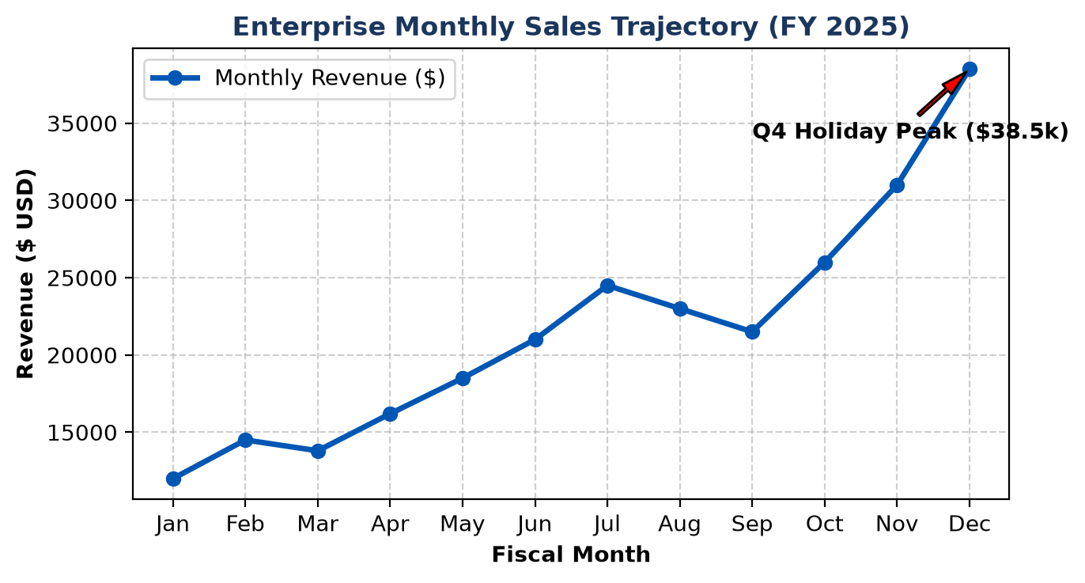
Figure: Enterprise Monthly Sales Trajectory with Annotated Peak
Activity 2: Plot Component Challenge (Fixing Incomplete Matplotlib Code)
Task: Identify missing plot components (Title, Axis Labels, Legend, Markers, Grid, Spines) in an incomplete script and produce a fully annotated professional figure.
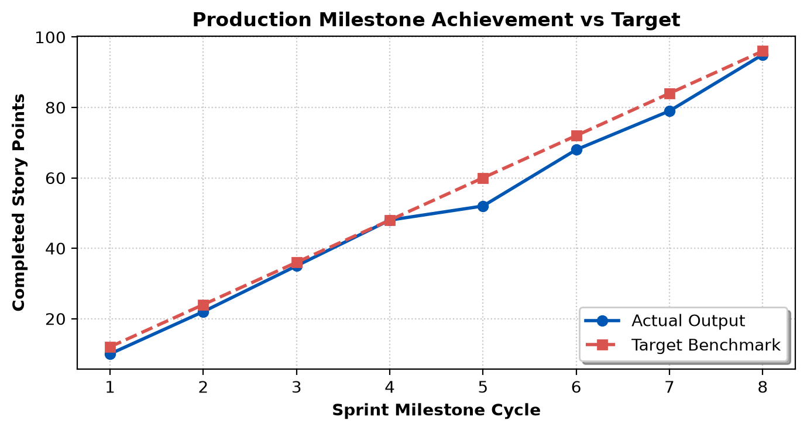
Figure: Production Milestone Achievement vs Target (Fully Formatted)
Activity 3: Compare Visualization Types (Line vs. Bar vs. Scatter)
Task: Compare Line plot, Bar plot, and Scatter plot on the same business metrics and determine the most effective visual communication medium.
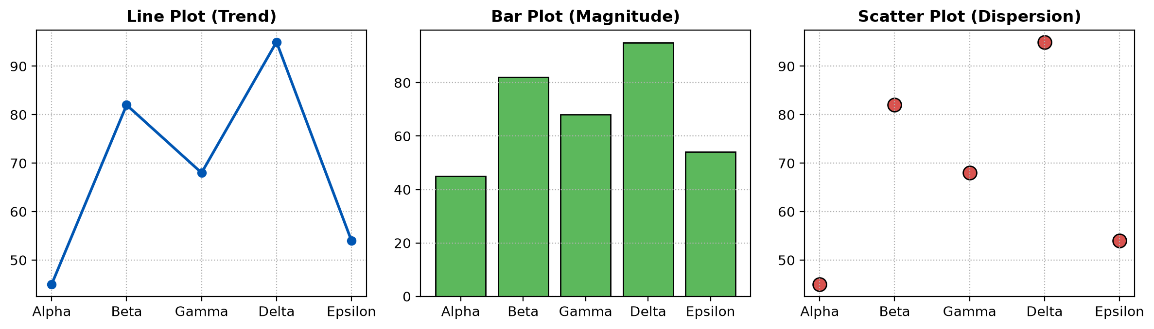
Figure: Comparative Visualization: Line (Trend) vs Bar (Magnitude) vs Scatter (Dispersion)
Activity 4: Pandas Direct Visualization Activity
Task: Create a DataFrame (Product, Sales, Profit, Units) and generate direct Pandas visualizations using df.plot().
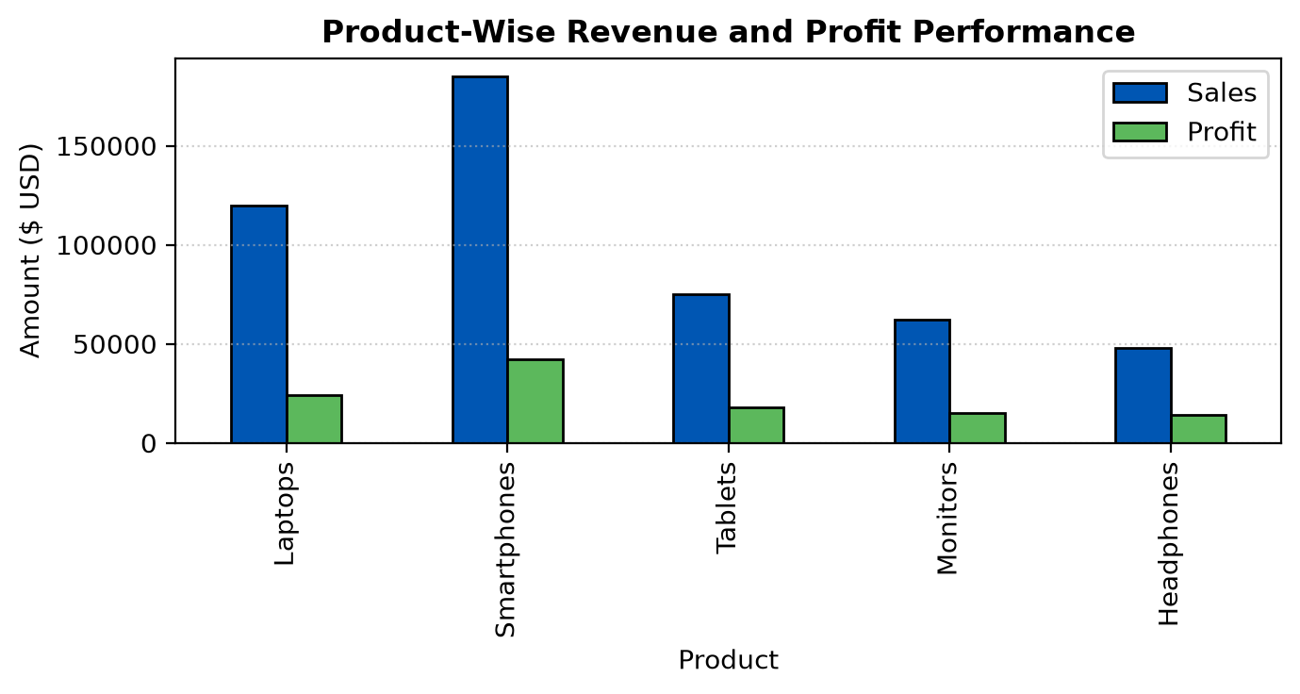
Figure: Product-Wise Revenue and Profit Grouped Bar Plot
Activity 5: Trend Visualization (Multi-Phase Trajectory Analysis)
Task: Decompose a multi-month metric to identify increasing, decreasing, and seasonal fluctuation phases.
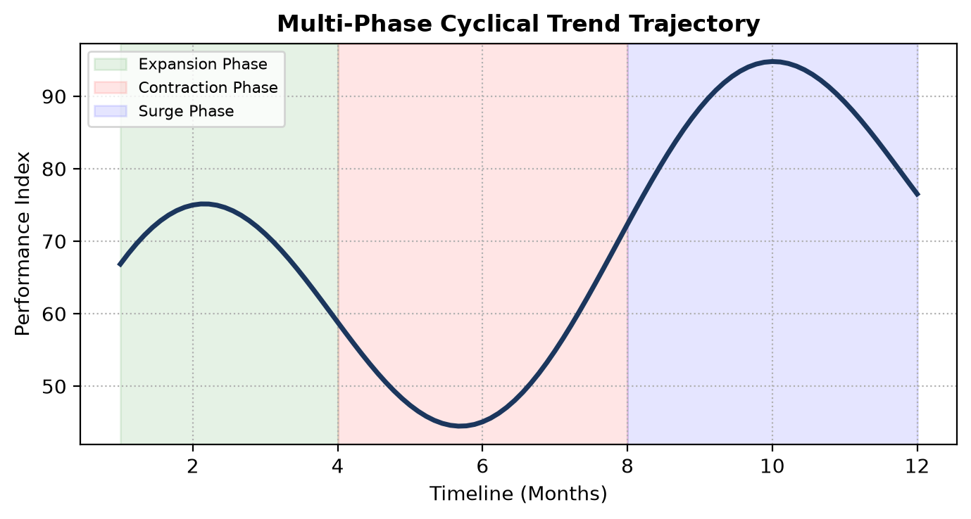
Figure: Multi-Phase Cyclical Trend Trajectory Decomposition
Activity 6: Relationship Visualization (Advertising Budget vs. Sales)
Task: Scatter plot of Advertising Budget ($k) vs Sales ($k), calculating Pearson r and OLS trendline.
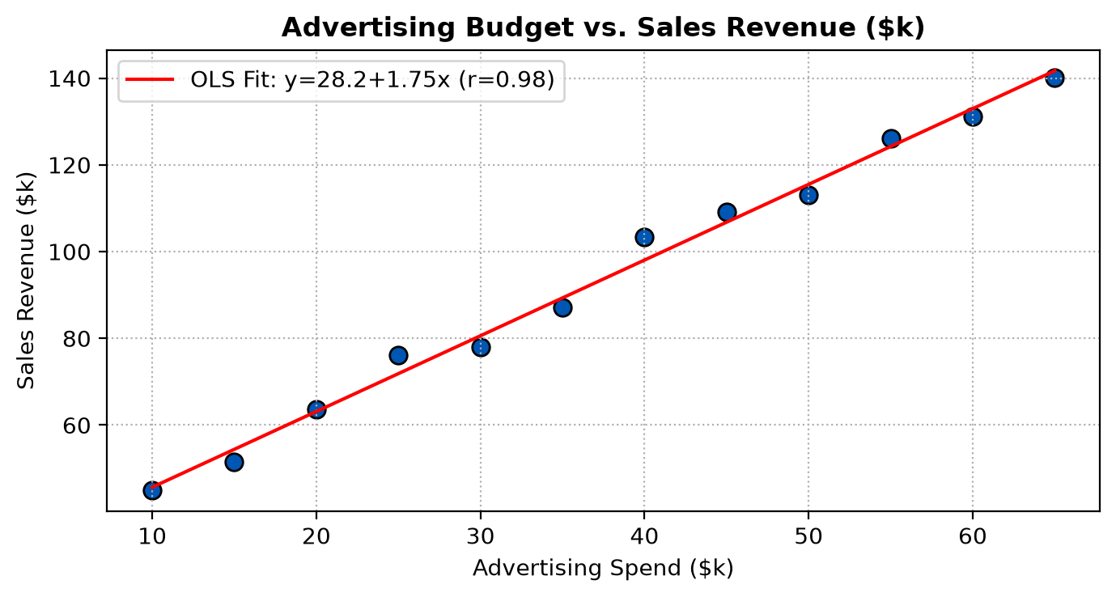
Figure: Advertising Spend vs Sales Revenue Scatter Plot with Fitted OLS Model
Activity 7: Distribution Visualization (Histogram & Normality Profiling)
Task: Analyze marks/salary distribution for center, spread, skewness, and modality.
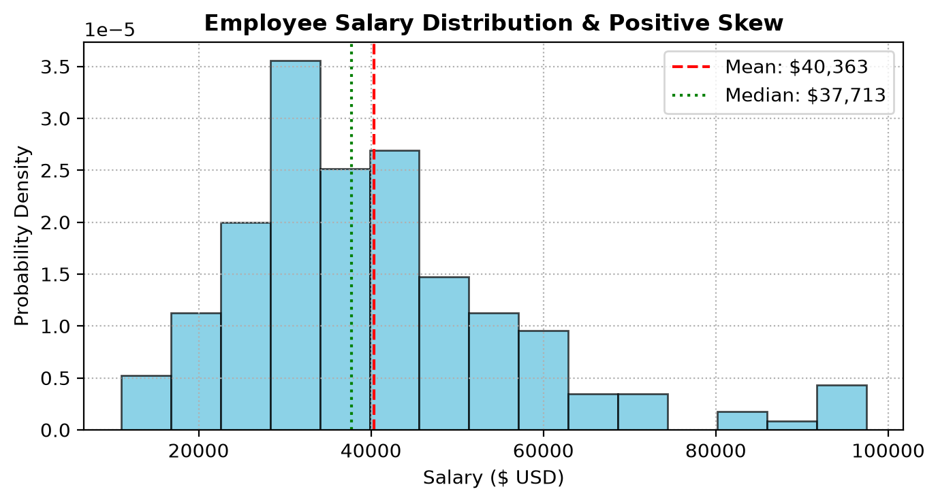
Figure: Employee Salary Distribution with Mean, Median and Positive Skew
Activity 8: Frequency Visualization (Categorical Bar Chart)
Task: Frequency distribution bar chart of corporate departmental headcounts.
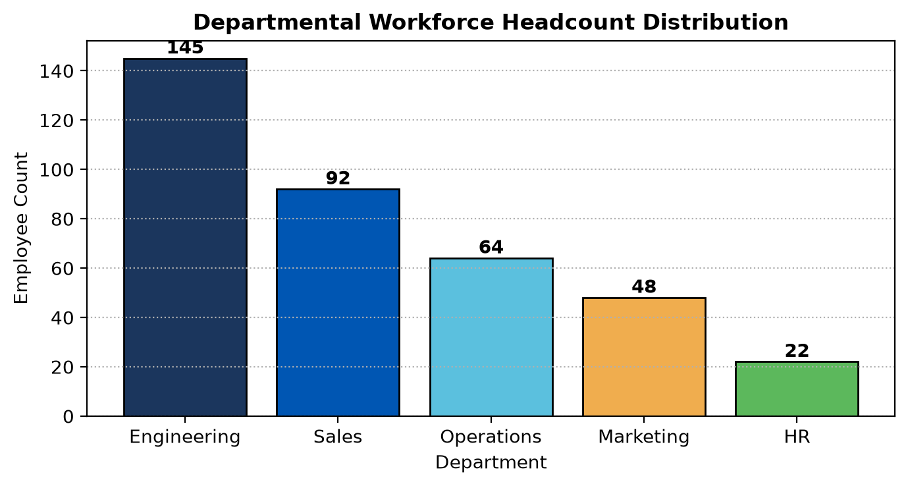
Figure: Departmental Workforce Headcount Bar Chart with Direct Value Labels
Activity 9: Scatter Matrix Visualization (Multivariate Covariance)
Task: Generate 4x4 pairwise scatter matrix across numerical features to isolate key linear and non-linear relationships.
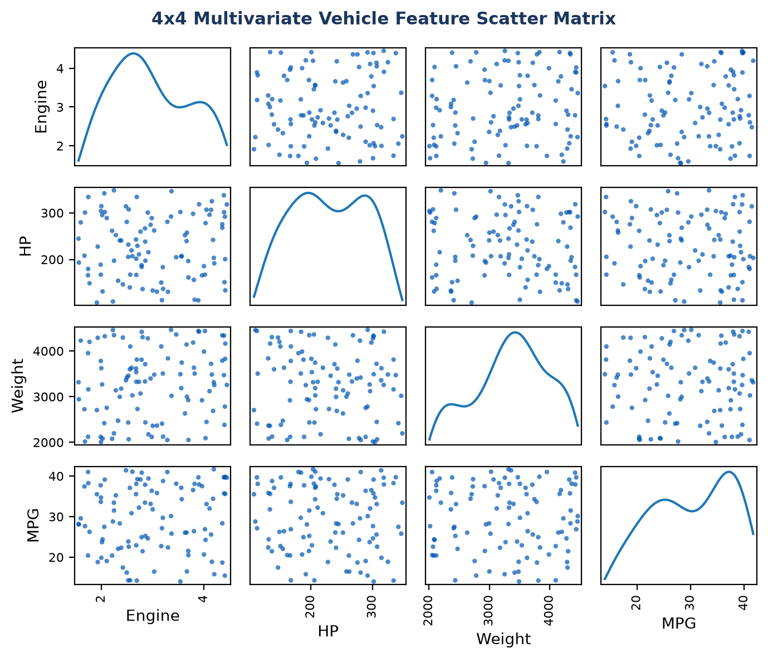
Figure: 4x4 Multivariate Vehicle Feature Scatter Matrix with KDE Diagonals
Activity 10: Lag Plot Visualization (Auto-regressive Dependencies)
Task: Evaluate time-series auto-regression using lag_plot(y, lag=1).
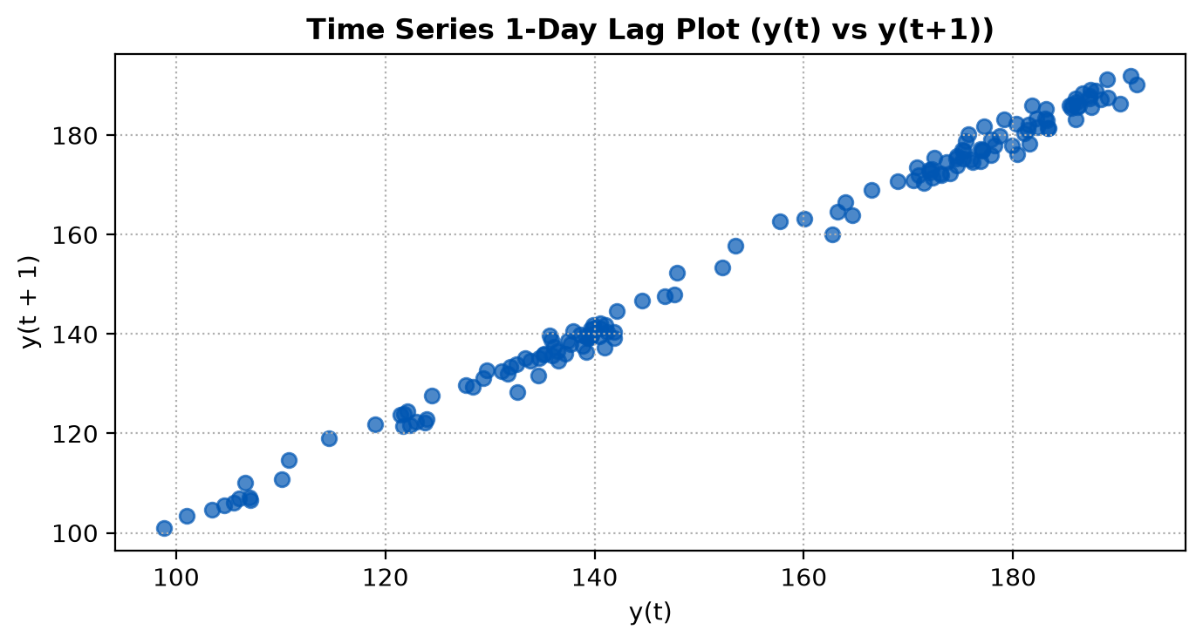
Figure: Time Series 1-Day Lag Plot (y(t) vs y(t+1)) Demonstrating Auto-Regressive Memory
Activity 11: Autocorrelation Visualization (ACF Periodicity)
Task: Plot autocorrelation across 50 lags to detect recurring seasonal cycles.
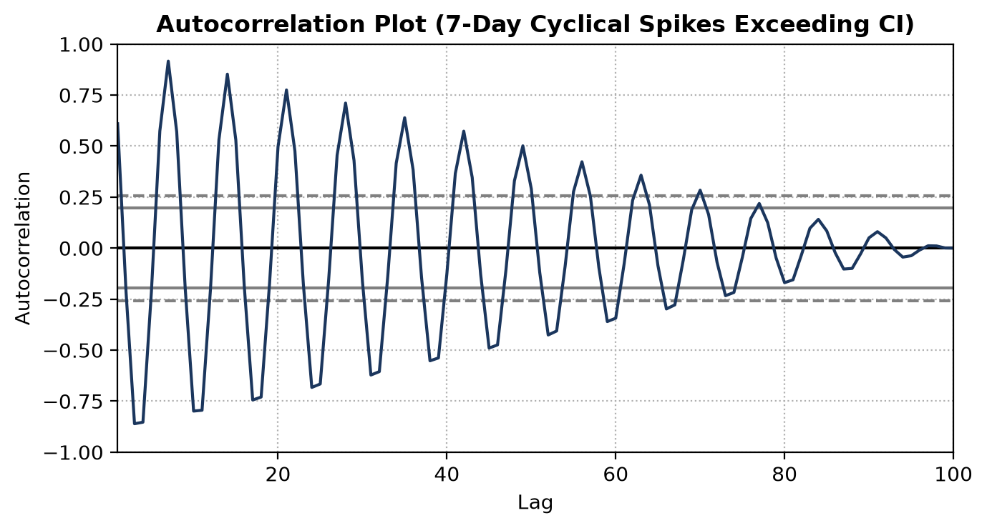
Figure: Autocorrelation Function Plot Demonstrating Statistically Significant Weekly Peaks
Activity 12: Bootstrap Visualization (Resampling Uncertainty Bounds)
Task: Repeatedly resample dataset (N=1000) to evaluate sampling distribution stability and estimate 95% confidence intervals.
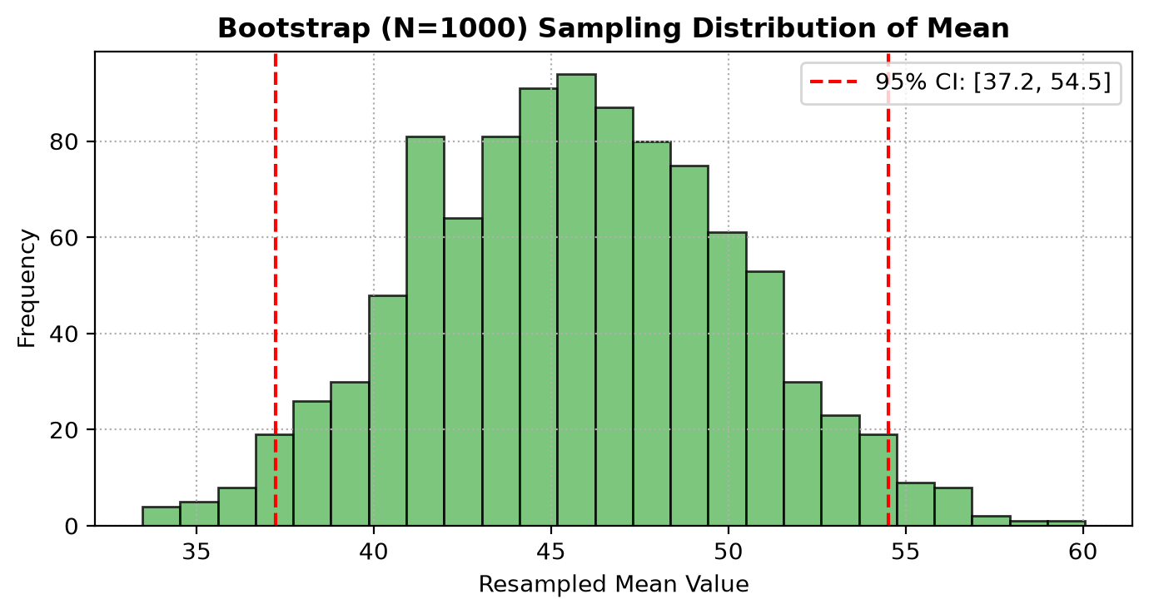
Figure: Bootstrap (N=1000) Resampling Sampling Distribution of Mean with 95% CI

